This is to certify that Contract # 2024-5015 for the following:

Trenchless Culvert Installation

was substantially performed on: October 17, 2024

Recommended by: 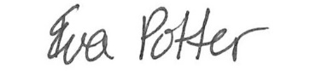Eva Potter, Jewell Eng. October 18, 2024
Contract Administrator Date Recommended

Approved by: 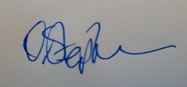 Darren Stephenson October 21, 2024
(payment certifier) Area Manager Construction Date Certified

437 McKeown Avenue, North Bay, ON P1B 9E4
Address

Haliburton County, Township of Stanhope
County/District/Regional Municipality/Town/City in which the Work is located

Highway 118, 1.3km West of Highway 35 Junction in Carnarvon
street address and city, town, etc. If no street address, the work location as described in the executed contract

Name of Owner: His Majesty The King in Right of Ontario as represented by the Minister of Transportation

Address for Service: Ministry of Transportation
447 McKeown Ave., North Bay, ON P1B 9S9

Name of Contractor: Braithwaite Drilling Inc.

Address for Service: 775 Listowel Line, Ennismore, ON

Office to which claim for lien must be given to preserve lien:

Ministry of Transportation of Ontario

Director, Legal Services Branch
125 Sir William Hearst Avenue, 1st Floor
Downsview, Ontario
M3M 0B5

This notice published in the Daily Commercial News on: Insert Date

Distribution: 1) Contractor, 2) Contract Administrator (file), 3) Team Lead, Contract Tendering – Contract Management Office, St. Catharines, 4) Construction Management Office

