Construction Lien Act, 1983

CERTIFICATE OF SUBSTANTIAL PERFORMANCE
OF THE CONTRACT UNDER SECTION 32 OF THE ACT

CITY OF GUELPH

The reconstruction of Speedvale Avenue East Grade Rail Crossing within the City of Guelph

This is to certify that the contract for the following improvement:

The contract work entails design, supply, installation, test, commissioning of Grade Crossing Systems, and associated restoration on Speedvale Avenue East – Guelph Junction Railway for the City of Guelph under Contract C#7200121615B.

to the above premises was substantially performed on: January 14, 2025,

Date certificate signed: January 24, 2025, 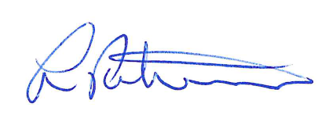
(payment officer)

Name of owner: Corporation of the City of Guelph

Address for service: 1 Carden Street, Guelph, Ontario, N1H 3A1

Name of Contractor: PNR Railworks Inc.

Address for service: 455 Silvercreek Parkway North
Guelph, ON
N1H 8M7

Name of payment certifier: Les Petroczi, General Manager

Address: 1 Carden Street, Guelph, Ontario, N1H 3A1

(Use A or B whichever is appropriate)

A. Identification of premises for preservation of liens:
Not Applicable
(where liens attach to pre mises, reference to lot and plan or instrument registration number)

B. Office to which claim for lien and affidavit must be given to preserve lien:

Stephen O’Brien, City Clerk, 1 Carden Street, Guelph Ontario, N1H 3A1
(where liens do not attach to premises)
O.Reg. 159/83, Form 6

