June 21, 2022

RAFAT General Contracting Inc.
8850 George Bolton Pkwy,
Bolton, ON
L7E 2Y4

ATTENTION: Zaid Madanat,

Re: RFQ-2110120

Attached is a Certificate of Substantial Performance, which must be advertised in the Daily Commercial News.

The 10 % Construction Lien Holdback will be released 45 days from the date of publication of the advertisement. A copy to be returned to our office along with the application for the 10% balance together with a WSIB certificate covering the Contractor’s standing as of the contract performance.

Thank you for your assistance and services in the successful completion of year four of this contract.

Sincerely,

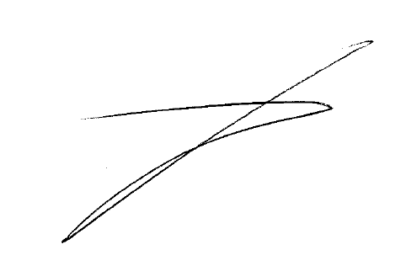

Joe Catania, C. Tech.
Capital Project Coordinator
City of Richmond Hill
Community Services Department, Public Works Operations Division

Attachment

Construction Lien Act, 1983
CERTIFICATE OF SUBSTANTIAL PERFORMANCE OF THE CONTRACT
Under Section 32 of the Act

...............................Region of York, Town of Richmond Hill........................................................
(County/District or Regional Municipality/City or Borough of Municipality of Metropolitan Toronto in which premises are situate)

................................P.O. Box 300, Richmond Hill, On. L4C-4Y5.................................................
(Street address and city, town, etc.or, if there is no street address, the location of the premises)

This is to certify that the contract for the following improvement: (Short description of the improvement)

RFQ-2110120 FOR THE SUPPLY AND OPERATion of five (19) FRONT END LOADERS FOR THE CLEARING OF SNOW FROM WIDE BENDS, CUL-DE-SACS AND OTHER RELATED SNOW REMOVAL SERVICES WITHIN THE TOWN OF RICHMOND HILL.

To the above premises was substantially performed on March 31, 2022.........................
(date substantially performed)

Date certificate signed: June 21, 2022…................ (payment certifier, where there is one)

...............................................................
(owner, where there is no payment certifier)

...............................................................
(contractor, where there is no payment certifier)

Name of owner: ......The Town of Richmond Hill................................................................
Address for service: .P.O. Box 300, Richmond Hill, ON. L4C4Y5......................................
Name of contractor: RAFAT General Contracting Inc ……...............
Address for service: 8850 George Bolton Pkwy, Bolton, ON L7E 2Y4
Name of payment certifier (where applicable): Joe Catania, Capital Project Coordinator.............................
Address: .1200 Elgin Mills Rd East P.O. Box 300, Richmond Hill, ON. L4C4Y5………..

(Use A or B whichever is appropriate)

A. Identification of premises for preservation of liens:

..................................................................................................................................
(Where liens attach to premises, reference to lot and plan or instrument registration number)
B. Office to which claim for lien and affidavit must be given to preserve lien:

....Town of Richmond Hill, P.O. Box 300, Richmond Hill, ON. L4C-4Y5.............
(where liens do not attach to premises)

