**FORM 9**

**CERTIFICATE OF SUBSTANTIAL PERFORMANCE OF THE**

**CONTRACT UNDER SECTION 32 OF THE ACT**

*Construction Act*

City of Toronto

………………………………………………………………………………………………………………………………………………………… (County/District/Regional Municipality/Town/City in which premises are situated)

Amesbury Sports Complex Outdoor Pool SGR Renovations, 155 Culford Rd., North York

………………………………………………………………………………………………………………………………………………………….

(street address and city, town, etc., or, if there is no street address, the location of the premises)

This is to certify that the contract for the following improvement:

Amesbury Sports Complex Outdoor Pool SGR Renovation

to the above premises was substantially performed on June 14, 2022

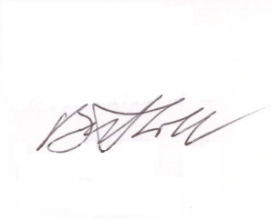

Bill Lobb Architect Date certificate signed: June 14, 2022

(payment certifier where there is one)

Name of owner: City of Toronto

Address for service: 55 John Street, 24th Floor, Toronto, ON M5V 3C6

Name of contractor: Trans Canada Construction

Address for service: 3250 Lenworth Dr.  Mississauga, ON L4X 2G1

Name of payment certifier (where applicable): Bill Lobb Architect

Address: 136 Northcote Ave., Suite 100, Toronto, Ontario M6J 3K5

(Use A or B, whichever is appropriate)

1. Identification of premises for preservation of liens:

………………………………………………………………………………………………………………………………………….

(if a lien attaches to the premises, a legal description of the premises, including all property identifier numbers and addresses for the premises)

1. Office to which claim for lien must be given to preserve lien:

For the preservation of Claims for Lien on or after the date s. 13(4) and s. 29(4) of the Construction Lien Amendment Act, 2017 come into force (currently, Oct. 1, 2019), Claims for Lien are to be submitted to the Clerk of the City of Toronto:

electronically as directed at www.toronto.ca/liens.

………………………………………………………………………………………………………………………………………….

(if the lien does not attach to the premises, the name and address of the person or body to whom

the claim for lien must be given)