

CERTIFICATE OF SUBSTANTIAL PERFORMANCE

OF THE CONTRACT UNDER SECTION 32 OF THE CONSTRUCTION LIEN ACT 1990
District of Kenora
(County/District or Regional Municipality/City in which premises are situated)
SOW Construction Limited Partnership, Kenora, Ontario
(Street address and city, town, etc., or, if there is no street address, the location of the premises)
504 Ninth St. North, Kenora, Ontario, P9N 2S8
This is to certify that the contract for the following improvement:
OSS#272612 – Construction of Repair of Washout on the English River Rd at Km 72 in the District of Kenora

to the above premises was substantially performed on: |  |  |  |  |  | October 08, 2022
 |  |  |  |  |  | (date substantially performed)
Date certificate signed: |  | October, 27, 2022 |  |  |  | N/A
 |  |  |  |  |  | (Signature of payment certifier where there is one)
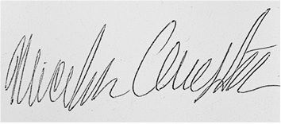
Signature of Superintendent or Zone staff
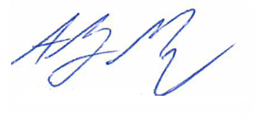

Signature of Contractor
 |  |  |  |  |  | (Signatures of owner and contractor, where there is no payment certifier)
Name of Owner: |  |  | Her Majesty the Queen in right of Ontario as represented by the Minister of Natural Resources
Address for Service: |  |  | MNRF, 808 Robertson St, Kenora, Ontario, P9N 1X9
Name of Contractor: |  |  | SOW Construction Limited Partnership
Address for Service: |  |  | 504 Ninth St. North, Kenora, Ontario, P9N 2S8
Name of Payment Certifier: |  |  | N/A
 |  |  | (where applicable)
Address: |  |  | N/A
(Use A or B whichever is appropriate)
A. | Identification of premises for preservation of liens:
 | (Where liens attached to premises, reference to a lot and plan or instrument registration number)
B. | Office to which claim for lien and affidavit must be given to preserve lien:
 | Director, Legal Services Branch Ministry of Natural Resources & Forestry Room 3420, Whitney Building 99 Wellesley Street West
 | (where liens do not attach to premises)

Distribution: Nicholas Clugston, MNRF Kenora
Moncrief Construction, Kenora

