This is to certify that Contract # 2022-5008 for the following:

Grading, Drainage & Electrical

**was substantially performed on:** September 5, 2023

**September 5, 2023

**Contract Administrator Date Recommended**

**Approved by:**  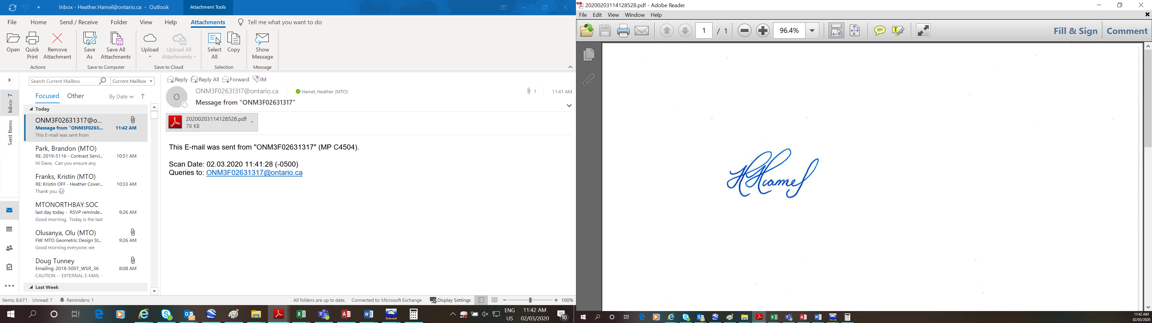________  October 18, 2023

**(payment certifier) Area Manager Construction Date Certified**

*447 McKeown Avenue, North Bay ON P1B 9S9*

**Address**



MTO Contract 2022-5008 District of Sudbury, Twp’s of Burwash, Secord & Dill

County/District/Regional Municipality/Town/City in which the Work is located

Highway 7279 From Trout Lake Road Northerly to Estaire Road Interchange 17.1 km.

street address and city, town, etc. If no street address, the work location as described in the executed contract

**Name of Owner:** His Majesty The King in Right of Ontario as represented by the Minister of Transportation

**Address for Service:** Ministry of Transportation

447 McKeown Avenue, North Bay ON P1B 9S9

**Name of Contractor: Pioneer Construction Inc.**

**Address for Service: 1 Ceasar Road, Sudbury ON P3E 5P3**

Office to which claim for lien must be given to preserve lien:

**Ministry of Transportation of Ontario**

**Director, Legal Services Branch**

**125 Sir William Hearst Avenue, 1st Floor**

**Downsview, Ontario**

**M3M 0B5**

**This notice published in the** *Insert the name of Construction Trade Newspaper as declared by the Contractor on PH-CC-817* **on:** *Insert Date*

Distribution: 1) Contractor

2) Contract Administrator (file)

3) Team Lead, Contract Tendering – Contract Management Office, St. Catharines

4) Construction Management Office