FORM 9

CERTIFICATE OF SUBSTANTIAL PERFORMANCE OF THE CONTRACT UNDER SECTION 32 OF THE ACT

*Construction Act*

City of Belleville

(County/District/Regional Municipality/Town/City in which premises are situated)

SJWS 350 Dundas Street West, Belleville, ON, K8P 1B2

(street address and city, town, etc., or, if there is no street address, the location of the premises)

This is to certify that the contract for the following improvement:

Project# 1087778-273883 Domestic Hot Water Distribution

(short description of the improvement)

to the above premises was substantially performed on September 01/2023

(date substantially performed)

Date certificate signed: December 13/2023

(owner and contractor, where there is no payment certifier)

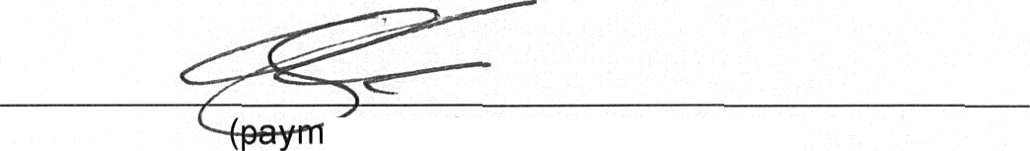

ént certifier where there is one)

Colliers Project Leaders Inc. on Name of owner: behalf of Infrastructure Ontario

Address for service: 27 Place D'Armes, Kingston, On, K7K 6Z6 Name of contractor: lntegracon Inc.

Address for service: 1730 McPherson Court, Unit &, Pickering, ON, L1W 3E6 Name of payment certifier (where applicable): **Kirkland** Engineering Ltd Address: 570 Water Street, Peterborough, ON, K9H 3M8

(Use A or B, whichever is appropriate)

A. Identification of premises for preservation of liens:

(if a lien attaches to the premises, a legal description of the premises, including all property identifier numbers and addresses for the premises)

§§ B. Office to which claim for lien must be given to preserve lien

Colliers Project Leaders Inc., 5255 Orbitor Drive, Suite 101, Mississauga, On, L4W 5M6

(if the lien does not attach to the premises, a concise description of the premises, including addresses, and the name and address of the person or body to whom the claim for lien must be given)

CA-9-E (2019/01)