September 6, 2024
Public Works Department
Engineering Services Division – Construction Section
905-546-4313 (Telephone) ~ 905-546-2463 (Facsimile)

Oakridge Group Inc.
340 Highway 20, RR#1
Hannon, Ontario L0R 1P0

Attention: Tim Wilson

Dear Sir:
NOTICE OF SUBSTANTIAL COMPLETION
Re: C15-49-23(H) Weirs Lane: 392m north of Johnston Avenue:
RW0447 Retaining Wall Rehabilitation and associated works
in the City of Hamilton

Please find enclosed the City of Hamilton's Certificate of Substantial Performance for the above noted contract.

Release of Holdback will be initiated following the submission of proof of advertisement in the Daily Commercial News, a WSIB clearance certificate, a statutory declaration and a sworn statement confirming that the contractor and its sub-contractors are in compliance with the City's Fair Wage Policy and Fair Wage Schedule, initial deficiency correction has been completed / verified and as built information has been submitted and accepted by the city.

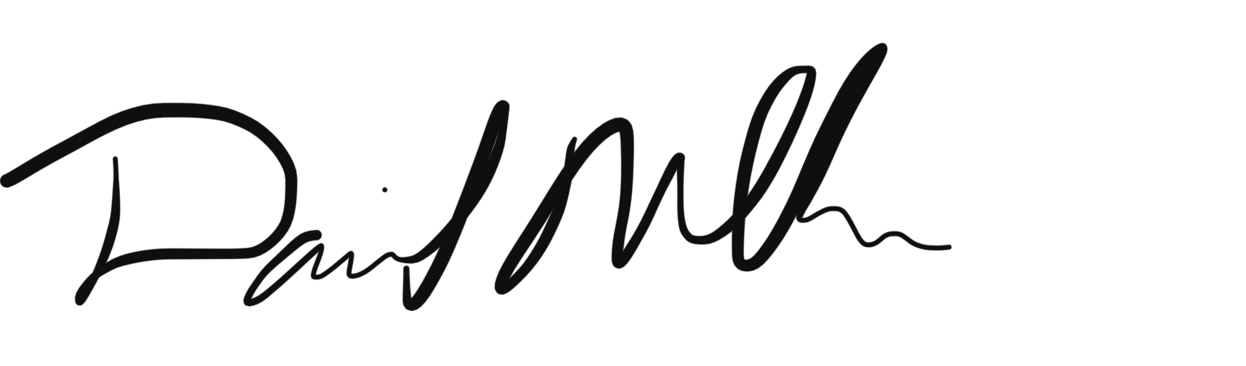

David Mullen
Project Manager, Construction Section
Engineering Services Division
City of Hamilton, Public Works Department

DM:amg

cc: Oral Riseing, Financial Assistant, Corporate Services
Peter Adetoye, Risk Management
Kathy MacLean, Risk Management
constructionservices@hamilton.ca
This is to Certify that Contract No. C15-49-23(H) for the following Improvements:

Weirs Lane: 392m north of Johnston Avenue:
RW0447 Retaining Wall Rehabilitation and associated works
in the City of Hamilton

Was SUBSTANTIALLY performed on: Tuesday, August 6, 2024

Date Certificate Signed: September 6, 2024 By: David Mullen
(Print)

NAME OF OWNER: THE CITY OF HAMILTON

ADDRESS FOR SERVICE: 100 King Street West, 2nd Floor, Hamilton Ontario, L8P 1A2

NAME OF CONTRACTOR: Oakridge Group Inc.

ADDRESS OF CONTRACTOR: 340 Highway 20, RR#1 Hannon, Ontario L0R 1P0

NAME OF PAYMENT CERTIFIER: David Mullen

TITLE OF PAYMENT CERTIFIER: Project Manager

SIGNATURE OF PAYMENT CERTIFIER:

ADDRESS FOR SERVICE: 100 King Street West, Hamilton, Ontario, L8P 1A2

(Use A or B, whichever is appropriate)
A) IDENTIFICATION OF PREMISES FOR PRESERVATION OF LIENS:

B) OFFICE TO WHICH CLAIM FOR LIEN AND AFFIDAVIT MUST BE GIVEN TO PRESERVE LIEN:

City Clerk's Department
71 Main Street West, Hamilton, Ontario L8P 4Y5
(Where Liens Do not Attach to Premises)

