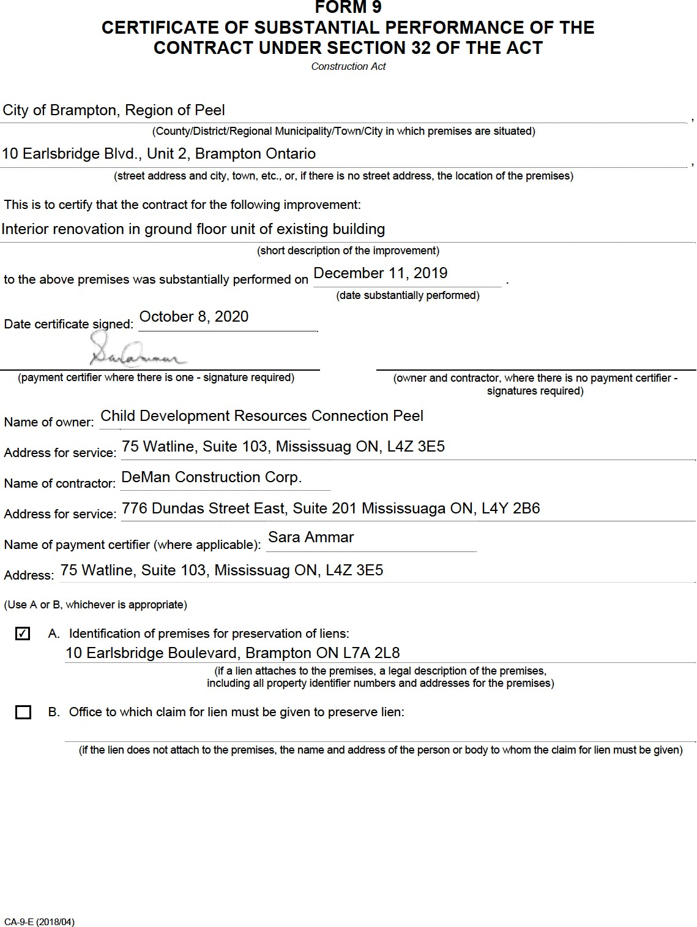

City of Brampton, Region of Peel

10 Earlsbridge Blvd., Unit 2, Brampton Ontario

Interior renovation in ground floor unit of existing building

December 11, 2019

October 8, 2020

Child Development Resources Connection Peel

75 Watline, Suite 103, Mississuag ON, L4Z 3E5 DeMan Construction Corp.

776 Dundas Street East, Suite 201 Mississuaga ON, L4Y 2B6

Sara Ammar

75 Watline, Suite 103, Mississuag ON, L4Z 3E5

✔

10 Earlsbridge Boulevard, Brampton ON L7A 2L8

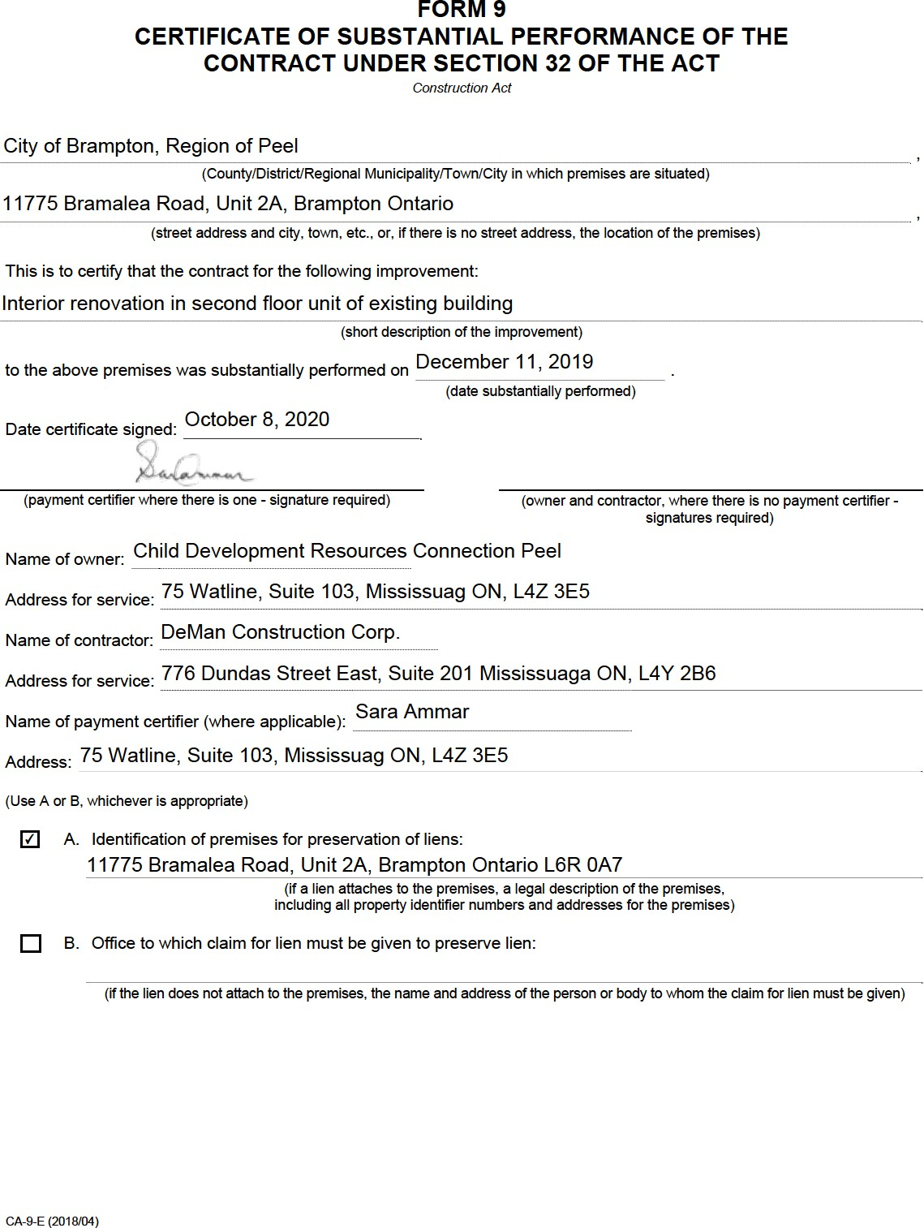

City of Brampton, Region of Peel

11775 Bramalea Road, Unit 2A, Brampton Ontario

Interior renovation in second floor unit of existing building

December 11, 2019

October 8, 2020

Child Development Resources Connection Peel

75 Watline, Suite 103, Mississuag ON, L4Z 3E5 DeMan Construction Corp.

776 Dundas Street East, Suite 201 Mississuaga ON, L4Y 2B6

Sara Ammar

75 Watline, Suite 103, Mississuag ON, L4Z 3E5

✔

11775 Bramalea Road, Unit 2A, Brampton Ontario L6R 0A7