CERTIFICATE OF SUBSTANTIAL PERFORMANCE
OF
RESURFACING OF GARDINER’S RD. FROM PRINCESS ST. TO BATH RD.

This is to certify that work pertaining to the following: Contract No.: ENG-2020-06

Resurfacing of Gardiner’s Rd. from Princess St. to Bath Rd., Contract ENG-2020-06 was substantially performed on September 4, 2020.

Name of Owner: The Corporation of the City of Kingston

Address of Service: 216 Ontario Street
Kingston, ON K7L 2Z3

Name of Contract Administrator: Ryan Costa

Name of Contractor: Coco Paving Inc.

Address of Contractor: 751 Dalton Ave., Kingston ON K7M 8N6

Identification of Work:
This contract generally includes Resurfacing of Gardiner’s Rd. from Princess St. to Bath Rd.

Office to which claim for lien and affidavit must be given to preserve lien:

On Property Title City Clerk
Land Registry Office Corporation of the City of Kingston
1201 Division St., Kingston, ON 216 Ontario St., Kingston, ON
K7K 6X4 K7L 2Z3

Date Certificate Signed: October 21, 2020

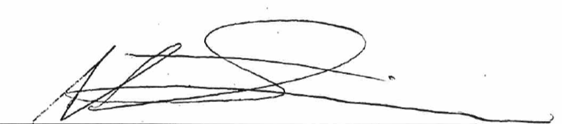
Signed: __________________________
Anthony Simmons
Construction Manager, Engineering Services

